A Child’s Drawing Analysis Research Paper
Olivia J. Krueger
University of Missouri, Columbia

A Child’s Drawing Analysis Research Paper
One of the most important parts of learning to become a teacher who truly impacts their students’ lives is to be able to see each child as their own individual and seek out the unique qualities within each and every one of them. Children’s imaginations run wild at every age while their thoughts and creativity further develops within their artwork as they grow.
After we were introduced to this assignment in class, we were to select a piece of children’s artwork then work with a partner to discuss both of our drawings to try and discover which stage each child most accurately belongs to. I came to the conclusion that the drawing I was given was drawn by a child who is in the Preschematic stage; they are between the ages of four to seven-years-old. I was able to rule out, the scribbling stage, which is done between the ages of two to four-years-old, because there weren’t just random lines or squiggles drawn on the page. There was a figure drawn in the middle of the paper, yet there were still a few scribbled areas, which I’m assuming were attempts to represent certain things. Although I knew this child was not in the scribbling stage, I further concluded they were most likely in Preschematic stage because the next stage is the Schematic stage. That stage shows more details in the drawings and each object drawn on the page is easily recognizable, which does not fully match up with the drawing I was provided.
In this drawing, the child looks to have drawn a bee’s body with a cat’s head attached to it. This child also included a sun in the upper right hand corner, maybe two black birds, the sky, and perhaps some grass at the bottom of the page. One of the many characteristics mentioned for this stage as written by Kellogg (1970) says, “shapes for things are geometric and lose their meaning when removed from the whole”. A few other characteristics that were mentioned were about how some objects that are drawn aren’t related to each other and the size of objects/placement of those objects are intentionally placed in a certain spot on the page to represent meaning.
Description and Analysis
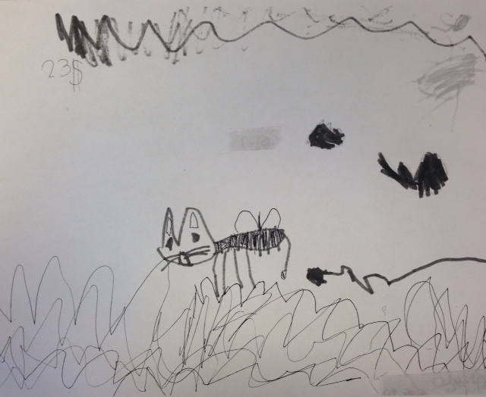
Seeing the unique artwork from children of different ages shows the progression they make throughout the years as they learn to understand the true meaning of each line or circle they’re drawing as their mind develops. According to Erickson and Young (1996), “children’s abilities to create drawings and to understand art develop in a parallel fashion to changes in their cognitive, emotional, social, and physical growth”. Since this child is still young, they haven’t had much time to grow in those areas to develop more accurate art skills. Looking at this drawing shows me that there’s a cat with a bee’s body featuring stripes, legs and wings.

Figure 1. An example of a child’s drawing
Seeing as to how the child knew to include those geometric detailed shapes shows that the drawing would definitely lose meaning if you took any of those details away. I noticed there is a sun draw in the upper right hand corner of this picture, which shows that this cat-bee is outside and it’s featured during the day. The other small detail included in this picture is mostly scribbles. Since there are scribbles at the top of the paper, I’m assuming those are to represent the sky since the sun is placed up there as well, but it’s harder to tell since the child only used black marker to draw. The bigger looped scribbles located at the bottom of the page seem to represent grass because it’s on the “ground” of the page and the cat-bee is hovering above it. I feel this is most accurate to what the picture is trying to show since Bang (2000) states, “because we tend to see pictures as extensions of our world, thinking of the top half as “sky” and the bottom half as “ground,” objects in the lower half of the picture feel more grounded—more attached to the earth and less mobile”. The location and placement of the objects drawn help imagine what the child was actually drawing. I think that the two black blobs represent birds because they’re drawn in the middle of the page and they seem to be flying higher than the cat-bee but are a little lower than where the sun is located. The last detail shown is the black line behind the cat-bee and the 23$ written on it. I feel that black line could be showing that the cat-bee is in motion and flying along through the air. I’m assuming that they wrote 23$ on it because their class was pretending to price their drawings to sell them, which is very cute.
Picking apart this picture and noticing the details within every inch of the drawing helps us, as teachers, try to get a better understanding of what these students are trying to draw. It can also help show us their interests and provide more detailed information about themselves. As I further analyzed this drawing, I felt as though this student really enjoys nature and being outdoors in the summertime. Perhaps they would like to be free and experience the fresh air on a warm day like the cat-bee is doing in this picture. I feel drawings can be interpreted in different ways, but they can help provide information about what someone’s interested in and could possible bring out the unique quality within each person.
Conclusion
“Overall, the more a teacher knows about their students developmentally and personally, the better able they are to provide a proper and appropriate education for them, making sure they are not left behind” (Luehrman & Unrath, 2006). Being a teacher requires getting to know each student so that they can connect and learn their strengths and weaknesses. Allowing children to draw and create art pieces helps teachers learn more about what makes each of the kids unique individuals. Allowing them to express their thoughts, emotions and creativity helps teachers see how far along each student has cognitively, emotionally, socially and personally grown. This helps make sure each child is on track with where they should be at certain ages. If teachers aren’t aware of what to expect from children at specific ages, then teaching within that classroom could quickly spiral downward. If they’re not aware of what to expect from kids at specific ages, then they could be missing important details that may be holding some students back, which results in a lot of catching up. Being aware of where children should be at specific age groups helps the teachers stay on track with the development of each child in their classroom.
Teachers should allow children to express themselves each day so that they can simply obtain more knowledge about either the student’s interests or just how they’re feeling that day. Allowing kids to take the first 15 minutes in the morning to draw their mood/how they’re feeling on a piece of paper can help show which children may need more assistance that day if some are feeling more down than others. Teachers are responsible for their student’s education within that classroom; figuring out how to incorporate art activities that are actively hands-on can show successful learning throughout the day and will help create better, more successful learning experiences.

References
Bang, M. (2000). Picture This: How Pictures Work. San Francisco, CA. Chronicle books LLC.

Erikson, M & Young, B. (1996). Art Advocacy: What Every Educator Should (But Maybe Doesn’t) Know.

Kellogg, R. (1970). Analyzing Children’s Art. Palo Alto, CA. National Press Books.

Luehrman, M & Unrath, K. (2006). Making Theories of Children’s Artistic Development Meaningful for Preservice Teachers.

